**2040 STRATEGIC PLAN**

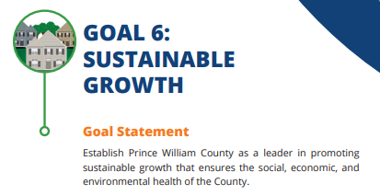

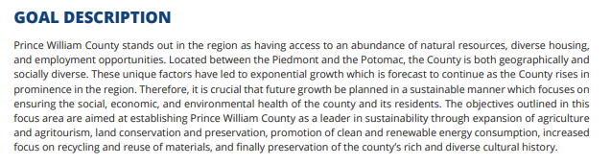

**GOAL 5: ENVIRONMENTAL CONSERVATION**



